Initial Time Plan

Partitions
The project would be split into:
- Pre-phase I planning and tasks.
- Three sprints for the project itself.
- Final tasks before phase II submission.
And all the charts are based on this legend:

Phase I Submission
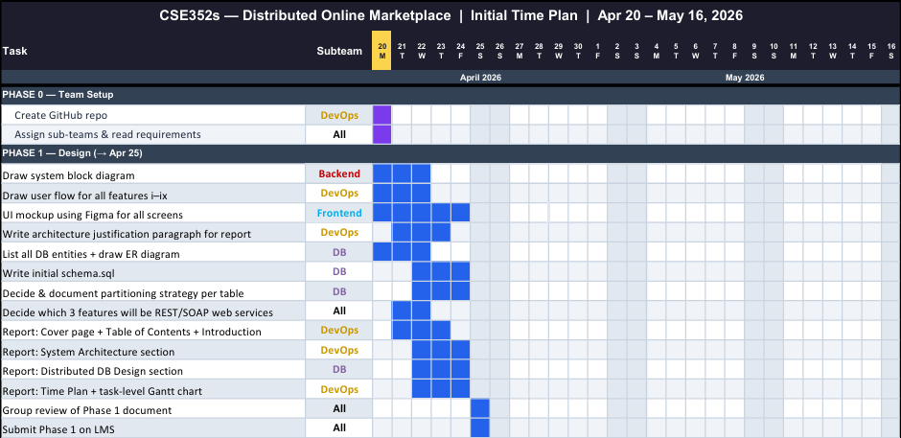

Sprint 1
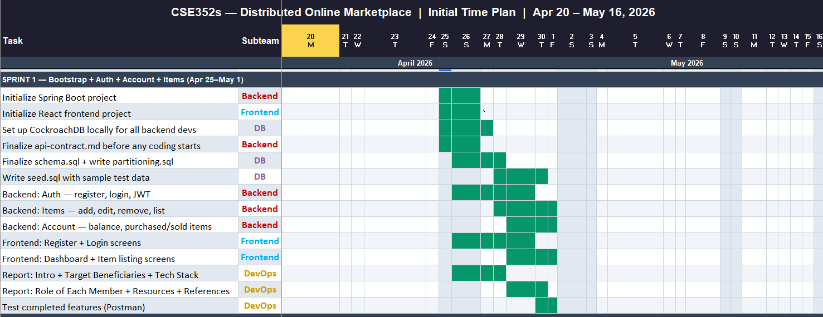

Sprint 2
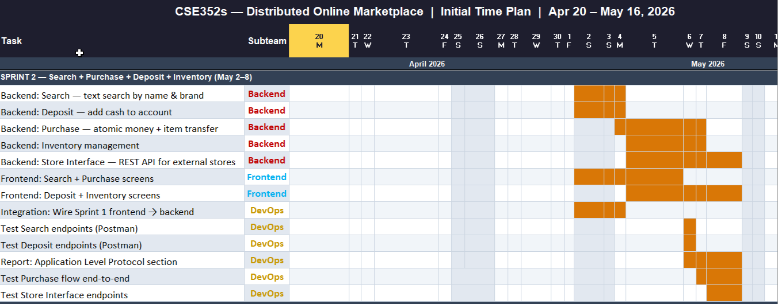

Sprint 3
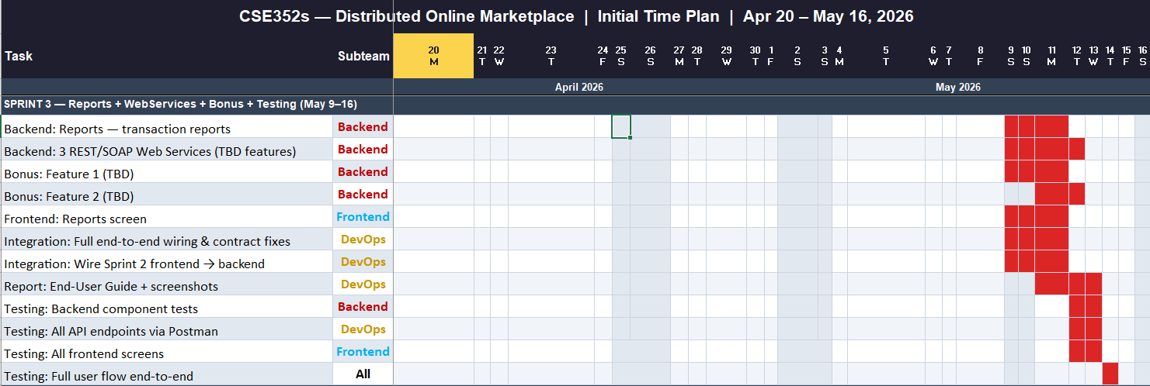

Phase II Submission
